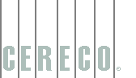 | 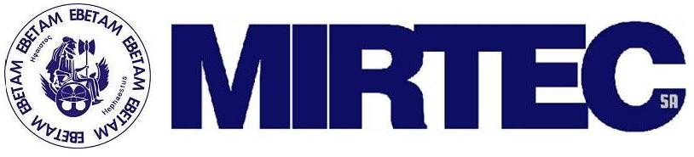 | 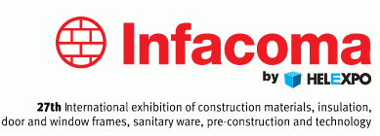 | 

Brokerage event in the field of Building Materials and Constructions at INFACOMA 2010

Supported by HELEXPO

18-21 February 2010, Pavillion 15

INFACOMA Fair, Thessaloniki, Greece

TECHNOLOGY PROFILE REGISTRATION FORM

Please fill this form and send it back by e-mail to nkanatsoulis@cereco.gr or a.gika@ebetam.gr no later than February, 14th 2010

Contact and organization details

Company/Organization:
Contact person name:
Position: | E-mail:
Address:
Zip code: | City:
Country: | Website:
Mobile Phone:
Year founded: | Turnover in 2009:
Sector of company activities:
Description of company activities, products and services

Do you have a booth on this fair?  Yes No | Booth No.  Mobile:

TECHNOLOGY PROFILE PARTICIPATION FORM

Organization’s Information to be published

Organization type  Small to medium-sized enterprise  Research institute  Inventor  Other (please specify)/ | Large Company  University  Consultant
Organization size
1-9 employees 10-49 employees 50-149 > 250

Technology Description (Technology Offer / Request)

Type of profile  Technology Offer  EU RTD Result | Technology Request  Know-how or expertise
Title:
(Please describe your technology in one sentence)

Description of the technology offered or requested:
(i.e. technical features, innovative aspects, competitive advantages)

Type of partner you are looking for:

Type of Agrrement:
License Aggrement
Technical co-operation
Joint Venture agreement
Research and Development
Commercial agreement
Financial Resources

Meeting Date and Time
18/02  Morning | Afternoon | Evening
19/02  Morning | Afternoon | Evening
20/02  Morning | Afternoon | Evening
21/02  Morning | Afternoon | Evening

THANK YOU!

