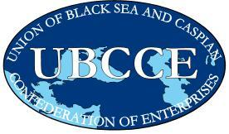
“The Voice of Business in the Black Sea and Caspian”

UBCCE THIRD BUSINESS FORUM
Hotel Nikopolis, Thessaloniki - Greece
12 - 13 November 2009

Registration Form

Participants information

Title:  Prof.  Dr.  other: |  |  |  Mr.  Ms.  Mrs.
Family name:
First name:
Organization:
Country: |  |  | Email:
Telephone: |  |  | Fax:

Please reply to
SEV: Ms Katerina Tsoutsika - Ms Nayla Sammour, ir@sev.org.gr
T. +30 211 500 6120 & +30 211 500 6116 – F. +30 210 3222 929
&
FING: Ms Vanessa Vlotides, eunet@sbbe.gr,
T. +30 2310 539817 – F. +30 2310 541491

Registration deadline: 30 October 2009

