 | Building Materials Match-making event  19-22 Feb 2009 | 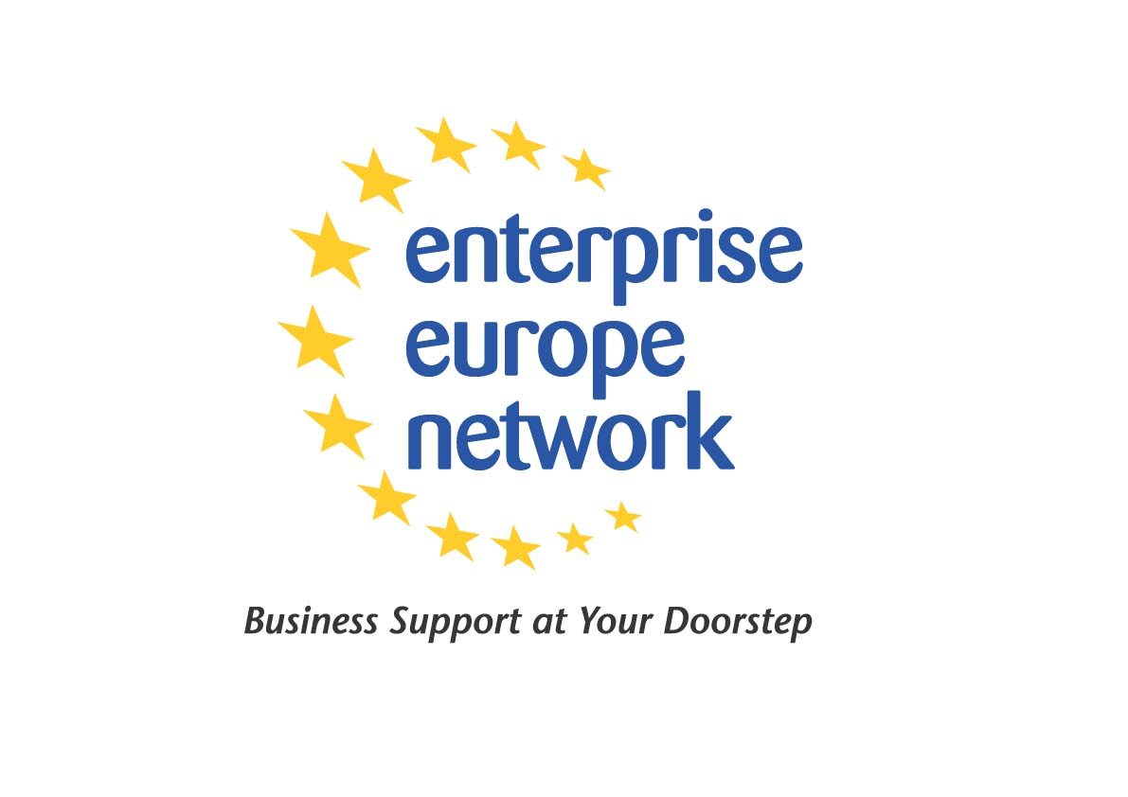
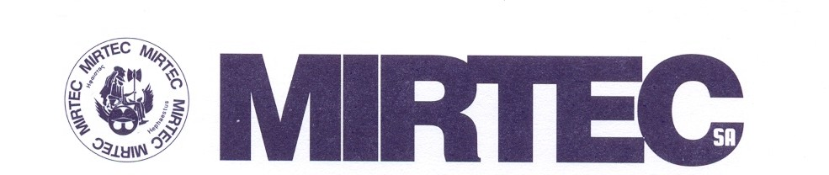

CERECO SA in collaboration with MIRTEC SA, both partners of the Enterprise Europe Network - Hellas are very pleased to announce an international match-making event in the field of building materials during the 26th edition of INFACOMA 2009, which will take place on the 19-22 February 2009, in Thessaloniki, Greece, at the venue of the exhibition center Helexpo.

INFACOMA is an International Exhibition for building materials, construction, insulation, and pre-construction technologies.
The main goal of the match-making event, during “INFACOMA 2009” is to encourage meetings between technology developers and technology users in order to foster technological and business co-operation in the field of building materials.
This event is an ideal platform to:
- Meet partners (especially from Balkan countries)
- Talk to potential users of technologies, products or processes.
- Get informed about the latest technological trends.
- Develop trans-national business contacts.
- Initiate technical co-operation or technology transfer.
Participants will be able to schedule in advance and attend one-to-one meetings with pre-selected business partners. More specifically on pre-arranged dates and time, visitors from the Balkan countries will meet the exhibitors, in order to start new co-operations.
For this purpose you are kindly requested to fill in and send to the organizers the registration form attached.
The participation to business meetings is free of charge.
Important dates:
- Registration & submission of profiles: 30 January 2009
- Requesting meetings: 6 February 2007
- Confirming meetings: 12 February 2009
- Receiving meeting schedules: 16 February 2009.
Information:
- Nikos Kanatsoulis, +30 22620 71226, nkanatsoulis@cereco.gr
- Elena Chrisikopoulou, +30 22620 71815, cereco@otenet.gr
- Alexandra Gika, +30 2109948432, a.gika@ebetam.gr

