Buy Korea 2011
Korea Trade-Investment Promotion Agency (KOTRA) is hosting Buy Korea 2011, a large scale business meeting event to boost mutual trade and cooperation between overseas renowned companies and competitive Korean partners. One-on-one meeting with Korean companies and the promotion of your company would be a great opportunity for you to do business with Korea. We would appreciate it if you could come and join this event

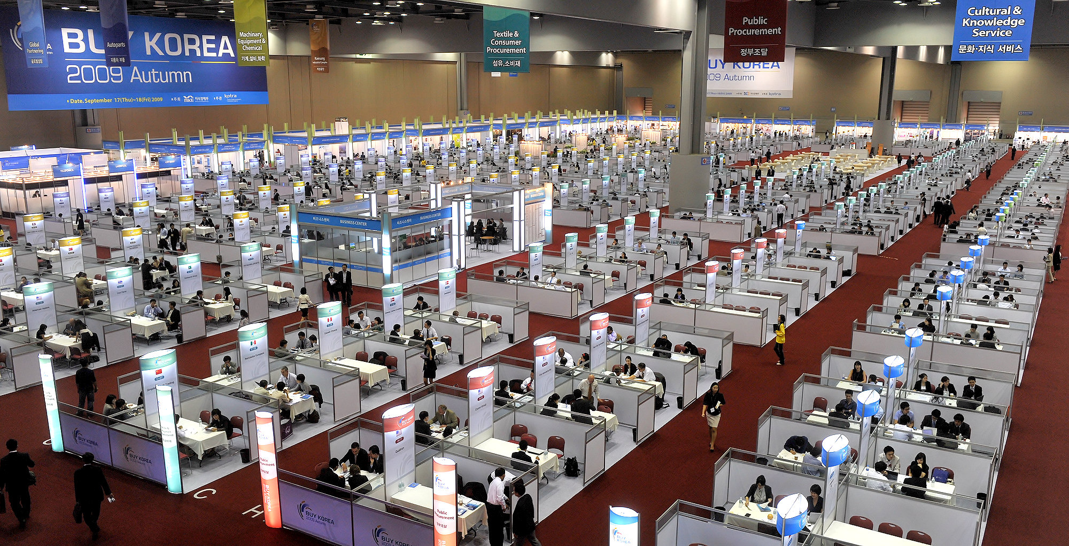
■ Buy Korea 2011

• Date & Time: January 11th, 2011 / 09:00 ~ 17:30
• Venue: KINTEX, Korea (www.kintex.com)
• Host: KOTRA

■ Programme

• One-on-One Meeting (Jan.11th)
- Pre-arranged business meeting with 5~7 companies in one day

• Exhibition (Jan.11th)
- 50 Best technology companies

• Business Luncheon (Jan.11th) hosted by the president of KOTRA

■ Support for Visitors attending Buy Korea 2011

• Two-night hotel accommodations may be given for one person per company
For details, please contact the Korea Business Center - Athens.

• Interpretation services will be provided during the 1:1 meetings.

■ Hotel Information

• Name : Coex Intercontinental Hotel, etc.
• Address : 3 Asem-gil, Gangnam-gu, Seoul, Korea 135-975
• Web site : www.seoul.intercontinental.com
• Tel : 82-2-3452-2500
• Fax : 82-2-3430-8000
• E-mail : coexseoul@interconti.com
*Detailed hotel information will be provided through your Korea Business Center when available.

■ Standard Itinerary

Time | Contents | Note
Jan. 10th | Arrival in Seoul and Check-in
Jan. 11th | One-on-one Meeting | KINTEX, Korea
09:00 ~ 10:00 | Business Meeting 1
10:00 ~ 11:00 | Business Meeting 2
11:00 ~ 12:00 | Business Meeting 3
12:00 ~ 13:30 | Business Luncheon | Standing Buffet
13:30 ~ 14:30 | Business Meeting 4
14:30 ~ 15:30 | Business Meeting 5
15:30 ~ 16:30 | Business Meeting 6
16:30 ~ 17:30 | Business Meeting 7
17:30 ~ | Back to the Hotel
Jan. 12th | Hotel Check-Out

